Main Components:

1. BlockChain Module
2. Driver Module
3. Serialization Module

Brief Descriptions

1. BlockChain Module

This module is the core component of our application’s backend. It maintains all BlockChain operations such as creating blocks, signature and mining. It contains 4 classes: BlockChain, Block, Transaction, and User. A BlockChain contains a list of Users and a List if Blocks. A Block contains a list of transactions. This module also uses the picosha2 header file library for hashing.

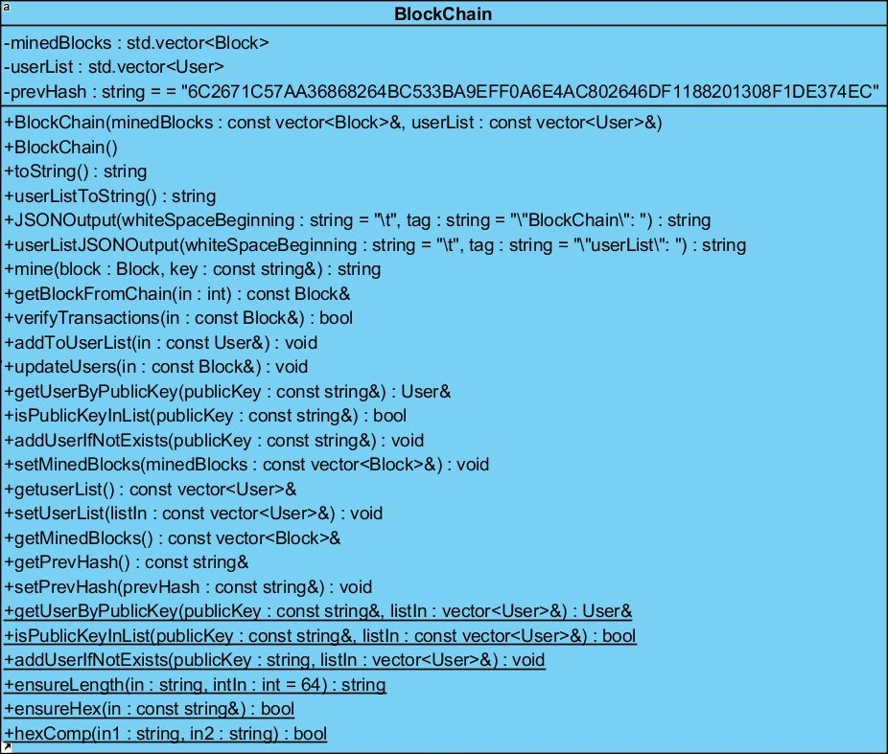

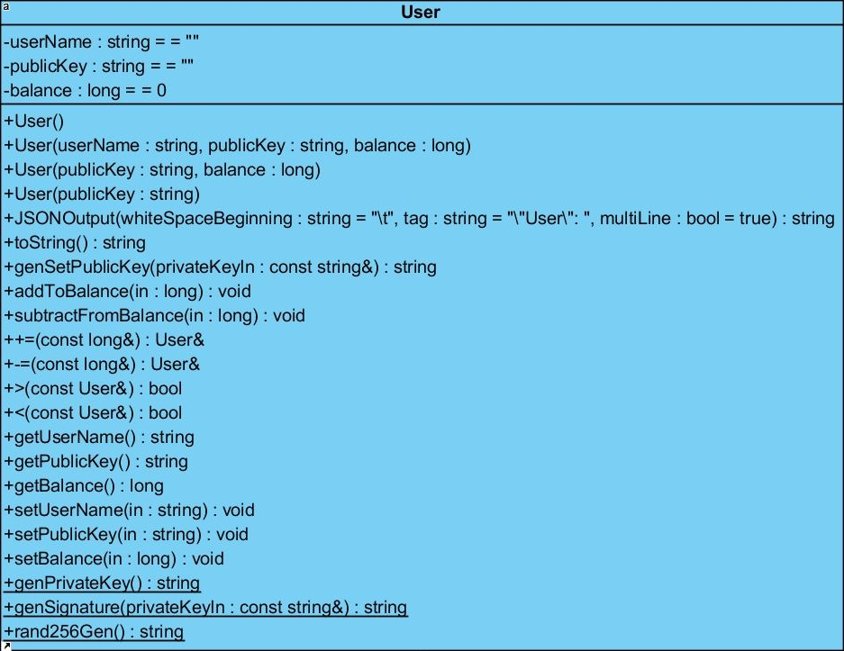

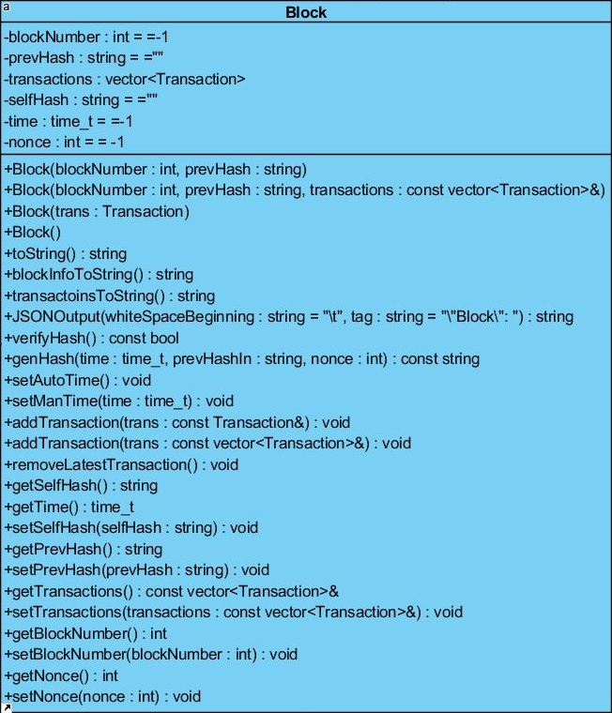

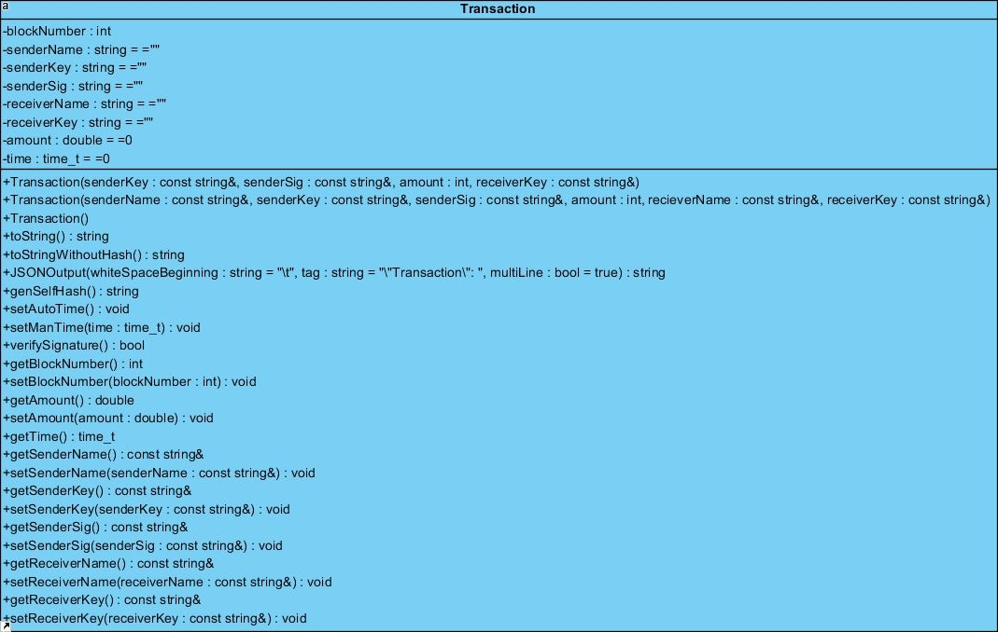

2. Driver Module

The Driver Module reads the Config file and performs the operations specified using functions from the Blockchain Module. It contains one class: Driver

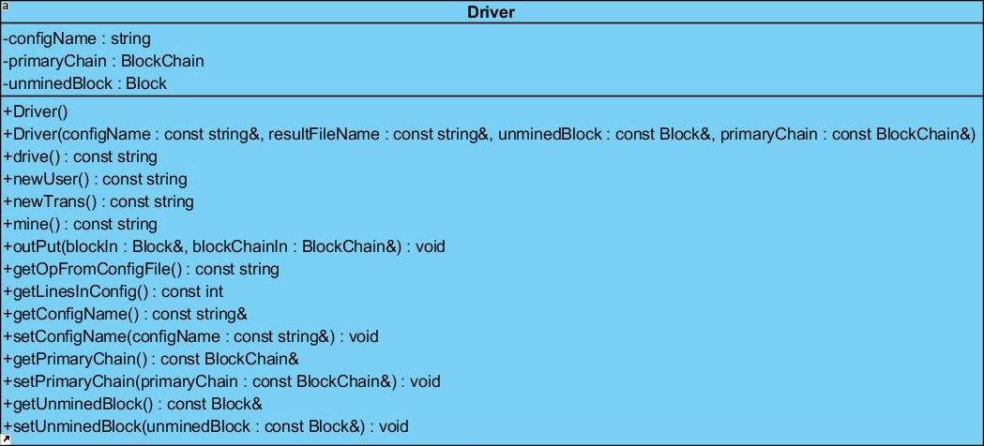

3. Serializer Module

The Serializer Module is responsible for Reading and Writing objects to files. At the beginning and end of the backend program it reads and writes the objects to file. It contains one class: Serializer.